**How to create config file and basic Parameters**

1.Using terminal we can use below command to create config file:  
 -**python3.10 odoo-bin - - addons-path=/home/odoo/workspace/odoo-18/addons -d database_name -p port_number --stop-after-init -s -c config_file_path**

2.run odoo service using **python3.10 odoo-bin -c config_file_path**

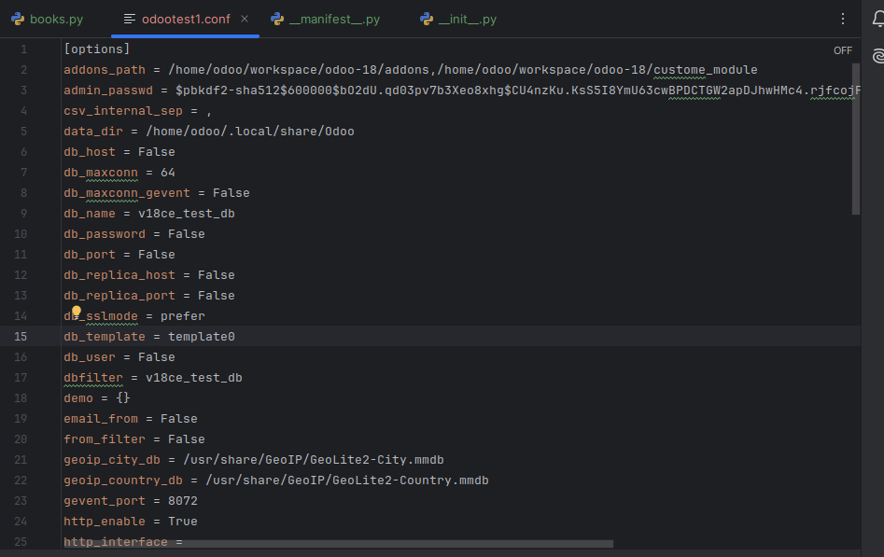

**Parameters:**1.addons-path:

-add path of custom module and also we can add odoo-18 addons path

2.db_name:  
 -give the database name in db_name parameter.False is set by default. If we specify any database name, we can only see that database in the Odoo database selector and manager.

3.db_port:  
 -Specifies the database port. The default value is None.

4.dbfilter:  
 -filter the database and select a specific database.

5.http_port:

-specific http port for odoo.